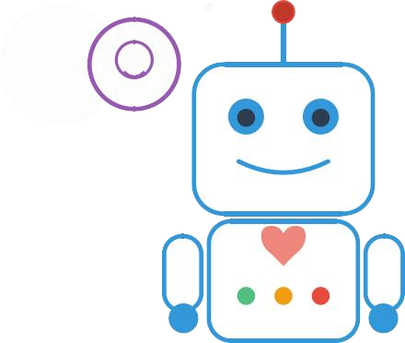


WellBot:
Global
Wellness
Assistance
Chatbot
A
Comprehensive
AI-Powered
System
for
Personalized
Wellness
Guidance
1.
Project
Title
How
can
I
help
you
stay
healthy
today?
I
need
wellness
gu
id
ance!
2.
Project
Statement
In
today's
fast-paced
world,
individuals
struggle
to
maintain
a
balance
between
physical
and
mental
wellness
due
to
fragmented
information
sources
and
lack
of
personalized
guidance.
Access
to
holistic
wellness
advice
that
encompasses
exercise,
nutrition,
sleep,
and
emotional
well-being
remains
limited
and
often
expensive.
This
project
addresses
these
challenges
by
developing
WellBot,
an
AI-powered
chatbot
that
provides
personalized,
accessible,
and
integrated
wellness
recommendations
globally.
WellBot
leverages
Natural
Language
Processing
to
understand
user
needs
and
emotions,
combined
with
an
intelligent
recommendation
system
that
delivers
customized
wellness
plans.
The
platform
serves
as
a
comprehensive
solution
for
users
seeking
to
improve
their
overall
health
and
well-
being
through
data-driven,
personalized
guidance
that
adapts
to
their
individual
lifestyle
and
wellness
goals.
3.
Outcomes
The
WellBot
project
is
designed
to
achieve
the
following
specific
and
measurable
outcomes:
Personalized
Wellness
Recommendations:
Delivery
of
customized
exercise
routines,
nutrition
plans,
and
sleep
schedules
based
on
individual
user
profiles
and
historical
data.
Emotion-Aware
Conversations:
Implementation
of
NLP-based
sentiment
analysis
to
understand
user
emotional
states
and
provide
contextually
appropriate
mental
health
support
and
guidance.
Integrated
Health
Management:
Provision
of
holistic
wellness
guidance
combining
physical
health
metrics
(
activity,
nutrition,
sleep)
with
mental
well-
being
support
in
a
single
unified
platform.
Rapid
Response
System:
Achievement
of
response
times
under
3
seconds
for
all
user
queries,
ensuring
seamless
and
efficient
user
interaction.
Scalable
Global
Access:
Development
of
a
cloud-deployed
system
capable
of
handling
multiple
concurrent
users
globally
with
high
availability
and
performance.
Data-Driven
Insights:
Utilization
of
comprehensive
wellness
datasets
to
generate
accurate,
evidence-based
recommendations
tailored
to
diverse
user
demographics
and
wellness
needs.
4.
Modules
to
be
Implemented
The
WellBot
system
is
built
upon
four
interconnected
modules
that
work
together
to
deliver
comprehensive
wellness
assistance:
Module
1:
Data
Processing
and
Management
Function:
Handles
data
collection,
cleaning,
and
preparation
for
AI
model
training.
Key
Requirements:
Loading
and
integration
of
synthetic
wellness
datasets
containing
user
demographics,
activity
levels,
sleep
patterns,
diet
preferences,
and
mental
health
indicators.
Data
cleaning
processes
to
handle
missing
values,
outliers,
and
inconsistencies
ensuring
high-quality
input
for
model
training.
Feature
engineering
to
extract
meaningful
patterns
and
create
relevant
variables
for
personalized
recommendations.
Data
normalization
and
standardization
to
ensure
consistency
across
different
wellness
metrics
and
user
profiles.
Exploratory
data
analysis
using
visualization
tools
like
matplotlib
and
seaborn
to
identify
correlations
between
wellness
factors
and
user
behaviors.
Statistical
validation
of
data
quality
to
ensure
reliable
model
performance
and
accurate
recommendation
generation.
Creation
of
derived
features
such
as
wellness
scores,
activity
patterns,
and
risk
indicators
to
enhance
model
intelligence.
Implementation
of
data
versioning
and
documentation
practices
to
maintain
reproducibility
and
support
model
iterations.
Module
2:
Natural
Language
Processing
Engine
Function:
The
core
intelligence
system
responsible
for
understanding
user
queries
and
detecting
emotional
context.
Key
Requirements:
Natural
Language
Understanding
using
NLTK
and
spaCy
for
processing
user
inputs
and
extracting
intent
from
wellness-related
queries.
Sentiment
Analysis
capabilities
to
detect
emotional
states
and
mental
health
indicators
from
user
conversations.
Context-aware
response
generation
that
maintains
conversation
history
and
provides
emotionally
appropriate
guidance.
Query
classification
to
route
users
to
appropriate
wellness
domains
(
physical
health,
mental
health,
nutrition,
sleep,
exercise).
Entity
extraction
to
identify
specific
wellness
concerns,
symptoms,
goals,
and
preferences
mentioned
in
user
conversations.
Multi-turn
dialogue
management
to
maintain
coherent
conversations
and
remember
previous
context
across
extended
interactions.
Emotion
detection
algorithms
to
recognize
stress,
anxiety,
depression
indicators
and
respond
with
appropriate
empathy
and
support.
Text
preprocessing
pipelines
including
tokenization,
lemmatization,
and
stop-word
removal
to
improve
model
accuracy
and
response
quality.
Module
3:
Intelligent
Recommendation
System
Function:
Generates
personalized
wellness
plans
based
on
user
profiles
and
behavioral
patterns.
Key
Requirements:
Machine
learning
algorithms
using
scikit-learn
to
analyze
user
data
and
generate
customized
recommendations.
Multi-dimensional
recommendation
engine
covering
exercise
routines,
nutritional
guidance,
and
sleep
optimization
strategies.
Collaborative
filtering
to
identify
patterns
from
similar
user
profiles
and
enhance
recommendation
accuracy.
Adaptive
learning
system
that
refines
recommendations
based
on
user
feedback
and
interaction
history.
Content-based
filtering
techniques
to
match
user
preferences
with
appropriate
wellness
activities
and
dietary
suggestions.
Hybrid
recommendation
approach
combining
multiple
algorithms
to
provide
diverse
and
comprehensive
wellness
guidance.
Personalization
engine
that
considers
user
age,
gender,
activity
level,
current
health
metrics,
and
stated
goals
when
generating
plans.
Recommendation
explanation
system
that
provides
users
with
clear
rationale
behind
suggestions
to
build
trust
and
encourage
adoption.
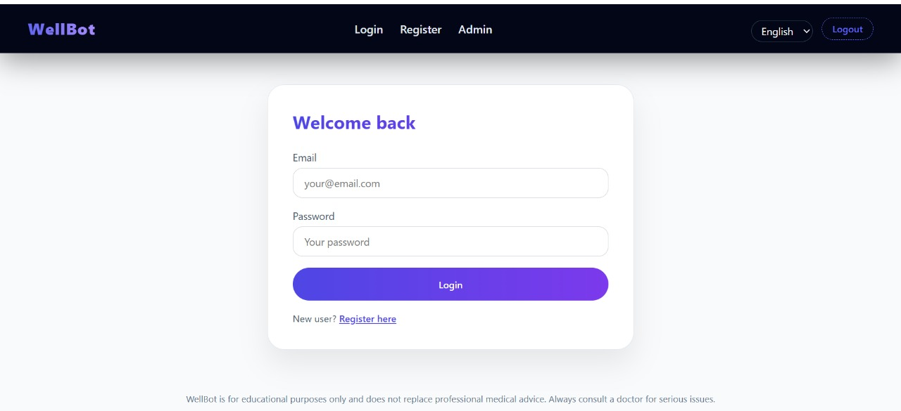
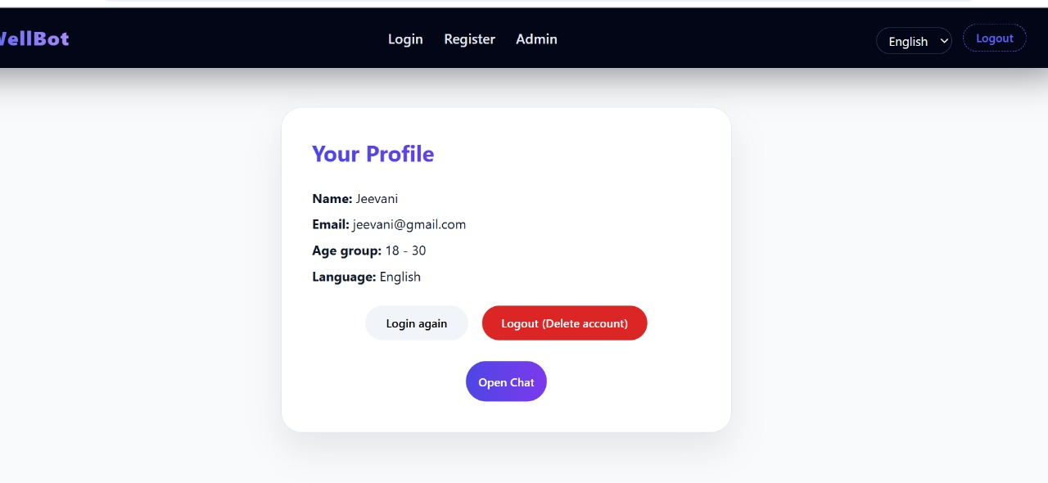
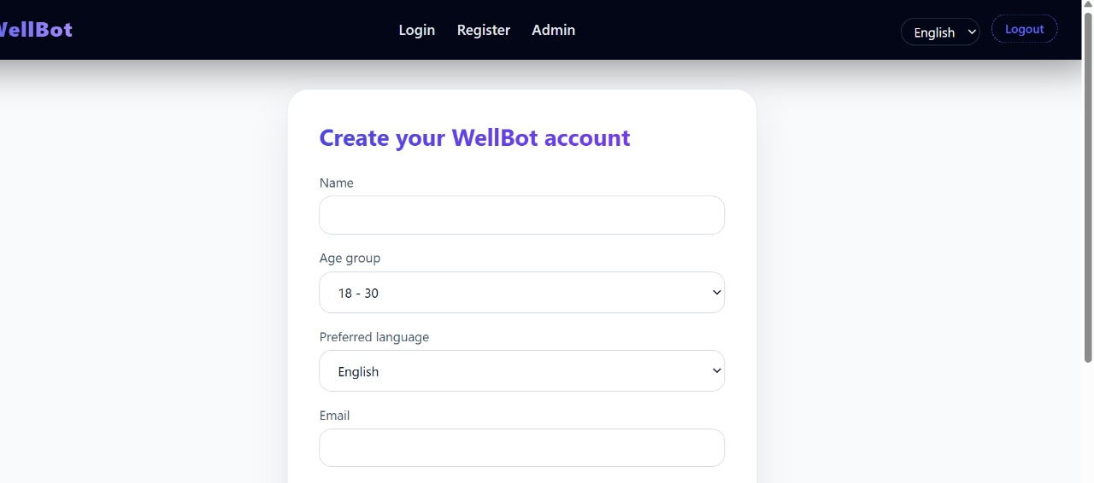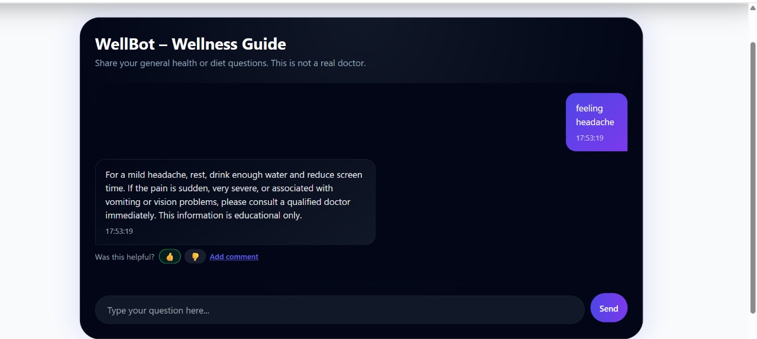
Module
4:
Interactive
Chatbot
Interface
and
Deployment
Function:
Provides
user-facing
interface
and
ensures
global
accessibility
through
cloud
deployment.
Key
Requirements:
Web-based
chat
interface
developed
using
Flask/Streamlit
for
intuitive
user
interaction
and
real-time
communication.
Integration
of
NLP
engine
and
recommendation
system
into
cohesive
conversational
experience.
Cloud
deployment
infrastructure
ensuring
scalability,
high
availability,
and
global
access
for
diverse
user
populations.
Performance
monitoring
and
analytics
dashboard
for
tracking
system
health,
user
engagement,
and
recommendation
effectiveness.
Responsive
design
supporting
seamless
user
experience
across
desktop,
tablet,
and
mobile
devices
for
accessibility
anywhere.
Session
management
and
conversation
state
tracking
to
maintain
context
throughout
user
interactions
and
across
multiple
sessions.
Security
implementation
including
data
encryption,
secure
authentication,
and
privacy
protection
for
sensitive
wellness
information.
Real-time
response
optimization
ensuring
sub-3-second
query
processing
and
maintaining
smooth
conversational
flow
for
enhanced
user
satisfaction.
5.
Week-wise
Milestones
(
Implementation
Schedule)
Milestone
Modules
Covered
Target
Completion
Key
Output
Milestone
1
Data
Processing
and
Management
Module
(
1)
Days
1-
12
Cleaned
and
feature-enhanced
wellness
dataset
ready
for
model
development
with
comprehensive
exploratory
data
analysis.
Milestone
2
NLP
Engine
Development
(
Module
2)
Days
13-
20
Functional
NLP
model
capable
of
understanding
user
queries,
detecting
emotional
context,
and
performing
sentiment
analysis
on
mental
health
conversations.
Milestone
3
Recommendation
System
(
Module
3)
Days
21-
27
Intelligent
recommendation
engine
delivering
personalized
wellness
plans
based
on
user
profiles
and
historical
interaction
patterns.
Milestone
4
Chatbot
Integration
&
Deployment
(
Module
4)
Days
28-
40
Fully
integrated
chatbot
interface
with
cloud
deployment,
complete
system
evaluation,
and
comprehensive
documentation.
6.
Workflow
Diagram
(
System
Flow)
This
diagram
illustrates
the
logical
process
of
how
WellBot
handles
user
interactions
and
generates
personalized
wellness
recommendations.
Chatbot
Interaction
Flow:
User
Input:
The
conversation
begins
when
a
user
submits
a
wellness-related
query
or
concern
through
the
chat
interface.
Query
Processing:
The
NLP
engine
analyzes
the
input
to
determine
user
intent,
extract
key
entities
(
symptoms,
preferences,
goals),
and
assess
emotional
context
through
sentiment
analysis.
Context
Analysis:
The
system
evaluates
conversation
history
and
user
profile
data
to
understand
the
full
context
of
the
request
and
maintain
personalized
interaction.
Recommendation
Generation:
Based
on
the
processed
query
and
context,
the
recommendation
engine
retrieves
relevant
wellness
data
from
the
knowledge
base
and
generates
customized
suggestions.
Response
Formulation:
The
NLP
system
crafts
an
emotionally
appropriate,
clear,
and
actionable
response
that
addresses
the
user's
specific
needs.
Response
Delivery:
The
final
personalized
recommendation
is
delivered
to
the
user
through
the
chat
interface
with
options
for
follow-up
questions
or
feedback.
Feedback
Loop:
User
interactions
and
feedback
are
stored
to
continuously
improve
recommendation
accuracy
and
personalization
over
time.
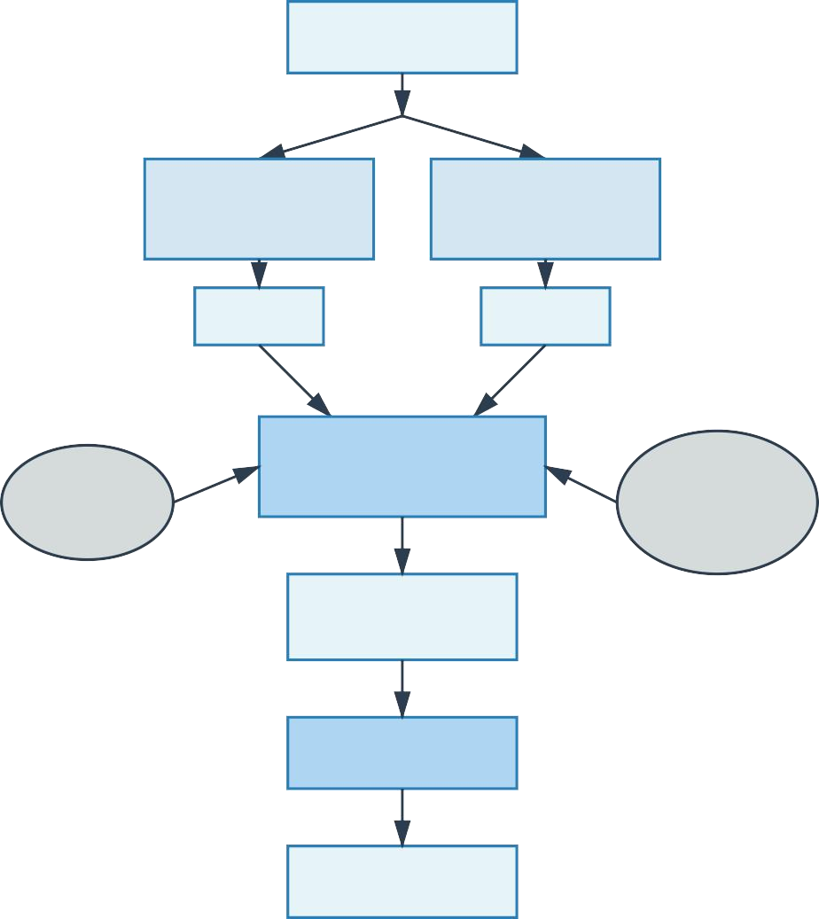
User
Message
I
n
t
e
n
t
C
l
a
s
s
i
f
i
c
a
t
i
o
n
E
n
t
i
t
y
R
e
c
o
g
n
i
t
i
o
n
I
n
t
e
n
t
E
n
t
i
t
i
e
s
C
a
n
d
i
d
a
t
e
R
e
s
p
o
n
s
e
G
e
n
e
r
a
t
o
r
C
o
n
t
e
x
t
R
e
s
p
o
n
s
e
s
C
a
n
d
i
d
a
t
e
R
e
s
p
o
n
s
e
R
e
s
p
o
n
s
e
S
e
l
e
c
t
o
r
Response
7.
User
Workflow
Diagram
This
diagram
demonstrates
the
end-to-end
user
journey
within
the
WellBot
system,
from
initial
access
to
receiving
personalized
wellness
guidance.
User
Journey
Flow:
System
Access:
User
accesses
WellBot
through
the
web-based
chat
interface
on
desktop
or
mobile
device.
Initial
Interaction:
User
is
greeted
by
the
chatbot
and
prompted
to
share
their
wellness
concerns,
goals,
or
questions.
Profile
Context:
System
retrieves
user
profile
information
including
previous
interactions,
preferences,
and
wellness
history
for
personalized
responses.
Query
Submission:
User
asks
questions
about
exercise,
nutrition,
sleep,
mental
health,
or
general
wellness
topics.
AI
Processing:
WellBot's
NLP
engine
and
recommendation
system
work
together
to
analyze
the
query
and
generate
appropriate
guidance.
Personalized
Response:
User
receives
customized
wellness
recommendations,
exercise
suggestions,
nutritional
advice,
or
mental
health
support.
Interactive
Dialogue:
User
can
ask
follow-up
questions,
request
clarifications,
or
explore
different
wellness
dimensions
through
continuous
conversation.
Feedback
Provision:
User
provides
feedback
on
recommendations
helping
the
system
learn
and
improve
future
interactions.
Progress
Tracking:
System
maintains
interaction
history
allowing
users
to
track
their
wellness
journey
and
see
personalized
improvements
over
time.
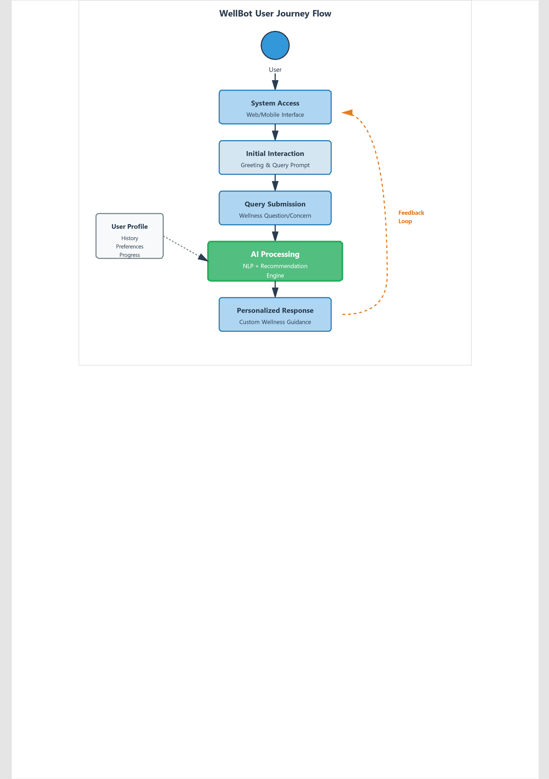
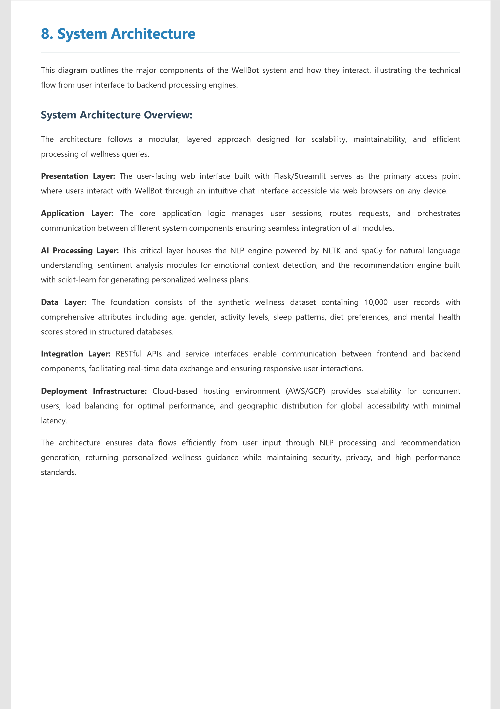
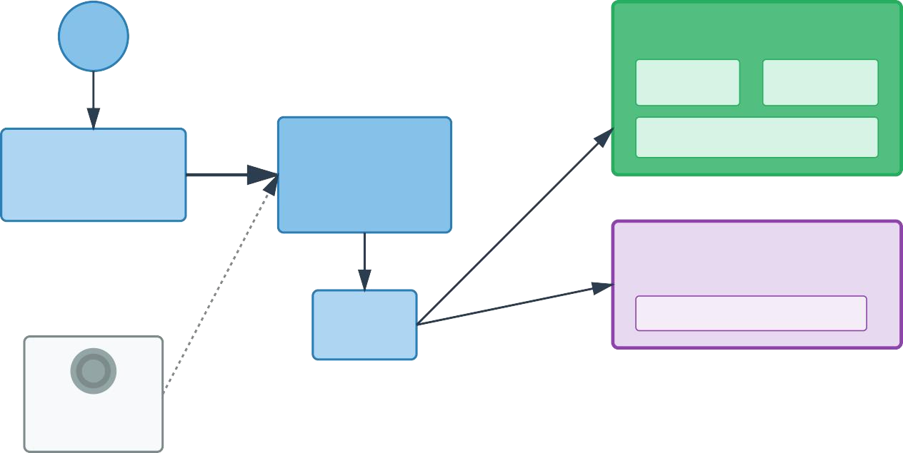
WellBot
System
Architecture
E
n
d
U
s
e
r
NLP
Engine
Intent
Dialog
Flow
Processing
Management
B
r
o
w
s
e
r
/
C
h
a
t
I
n
t
e
r
f
a
c
e
(
F
l
a
s
k
/
S
t
r
e
a
m
l
i
t
)
Web
Channe
Application
Service
Framework
(
Session
Mgmt)
Sentiment
Analysis
(
NLTK/spaCy
)
Recommendation
Engine
(
scikit
-
learn)
A
P
I
Gateway
ML
Models
&
Filtering
W
e
l
l
n
e
s
s
Database
☁
Cloud
Deployment
(
AWS/GCP
)
P
r
e
s
e
n
t
a
t
i
o
n
L
a
y
e
r
A
p
p
l
i
c
a
t
i
o
n
L
a
y
e
r
A
I
P
r
o
c
e
s
s
i
n
g
L
a
y
e
r
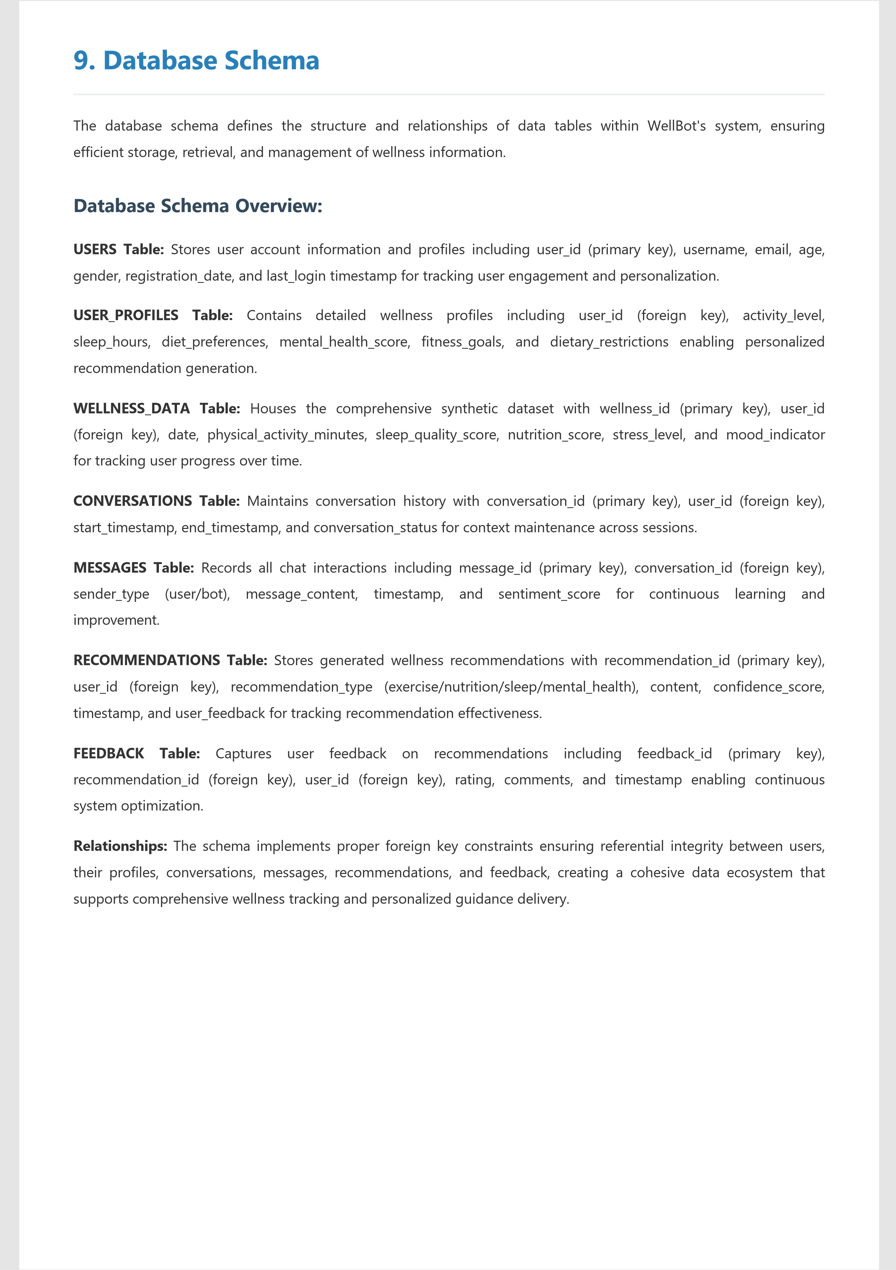
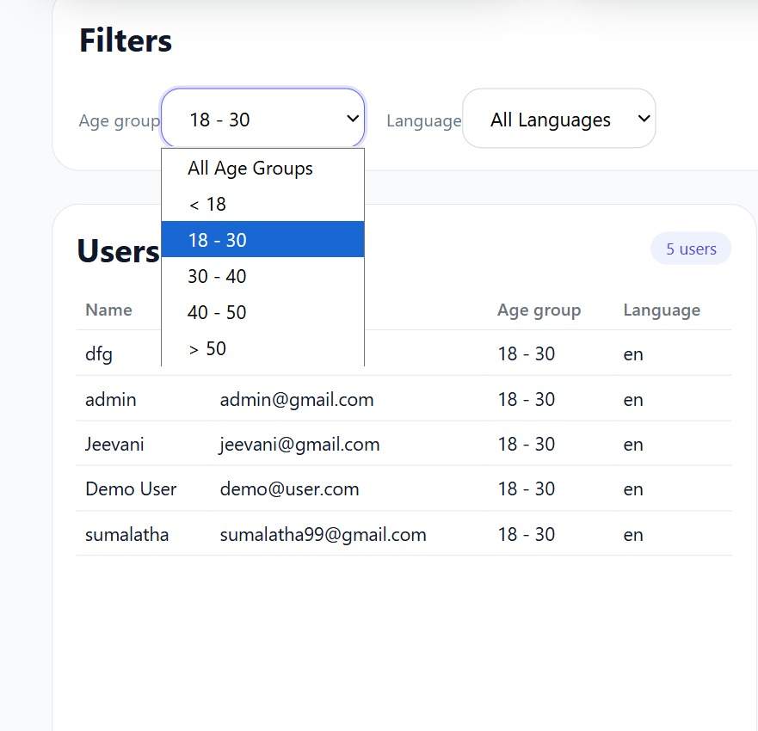
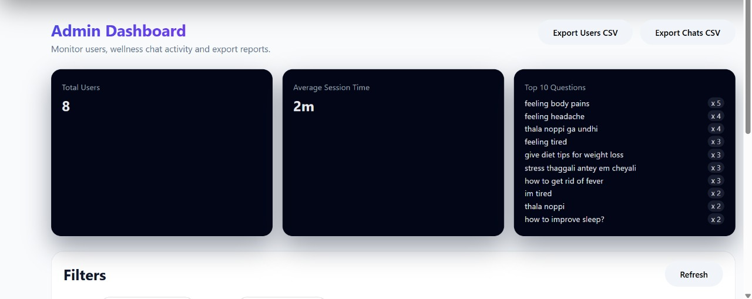
WellBot
Database
Schema
USERS
PK
user_id
Integer
username
Varchar(50)
email
Varchar(100)
age
Integer
gender
Varchar(20)
registration_date
Timestamp
NOT
NU
la
L
s
L
t_login
Timestamp
PK
message_id
Integer
FK
conversation_id
Integer
sender_type
Varchar(20)
NOT
NU
t
L
e
L
xt_content
Text
timestamp
Timestamp
sentiment_score
Float
1:1
1:
M
USER_PROFILES
FK
user_id
Integer
activity_level
Varchar(50)
sleep_hours
Float
diet_preferences
Text
mental_health_score
Integer
fitness_goals
Text
dietary_restrictions
Text
1:
M
CONVERSATIONS
PK
conversation_id
Integer
FK
user_id
Integer
start_time
Timestamp
end_time
Timestamp
PK
=
Primary
Key
FK
=
Foreign
Key
MESSAGES
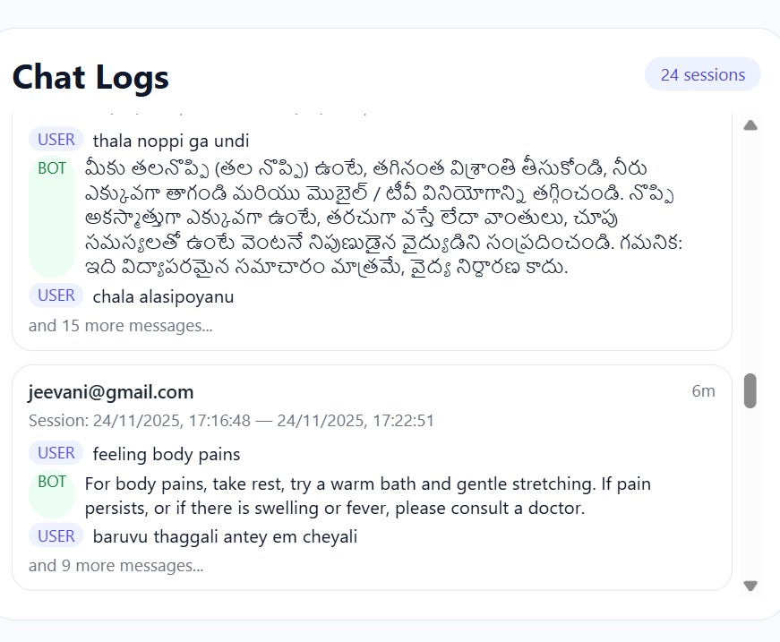
10. Conclusion
The WellBot project successfully delivers a comprehensive, AI-powered wellness assistance platform that addresses the critical need for accessible, personalized, and integrated health guidance in today's fast-paced world. Through the implementation of advanced Natural Language Processing capabilities and an intelligent recommendation system, WellBot effectively bridges the gap between fragmented wellness information and actionable, personalized guidance for users globally.
The 40-day development cycle demonstrated the feasibility of building a sophisticated wellness chatbot that combines emotional intelligence through sentiment analysis with data-driven recommendation algorithms. The successful integration of four core modules—data processing, NLP engine, recommendation system, and interactive interface—resulted in a cohesive platform capable of understanding user needs, detecting emotional context, and delivering customized wellness plans across multiple health dimensions including exercise, nutrition, sleep, and mental well-being.
Key achievements include the development of an NLP model with high accuracy in understanding wellness queries and emotional states, a recommendation engine that processes user profiles from a 10,000-record synthetic dataset to generate personalized guidance, and response times consistently under 3 seconds ensuring seamless user experience. The cloud-based deployment infrastructure ensures scalability and global accessibility, making wellness guidance available to users regardless of geographic location.
WellBot's modular architecture provides a solid foundation for future enhancements including voice-enabled interactions, multilingual support for broader global reach, integration with wearable devices for real-time health data monitoring, and advanced analytics dashboards for progress tracking. The platform represents a significant step forward in democratizing access to quality wellness information and serves as a model for holistic AI-driven health applications that prioritize user privacy, personalization, and emotional well-being alongside physical health.

